

 Building Face-detection App on AWS

Under guidance of:

**Aravind Raghavan**

AWS Certified Cloud Expert

Presented by: **Lathesh Neikar K H**

Usn:4SU16CS051

Phone:9380932584

[Email : lathesh.neikar@gmail.com](mailto:Email%20:%20lathesh.neikar@gmail.com)

College: SDM institute of technology, Ujire DK

Screenshots

1. AWS login screen with username

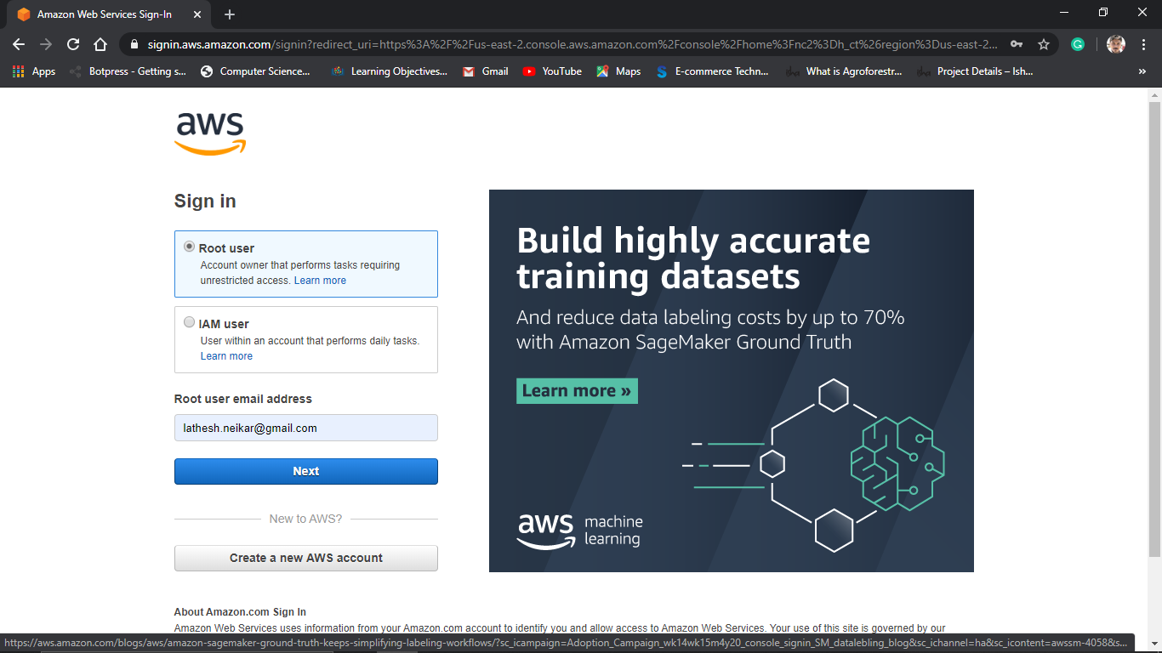

AWS Management Console

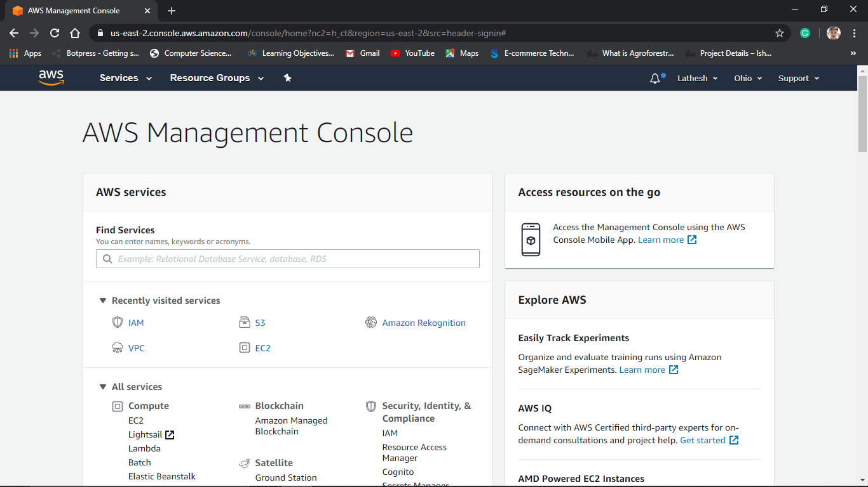

1. EC2 Dashboard

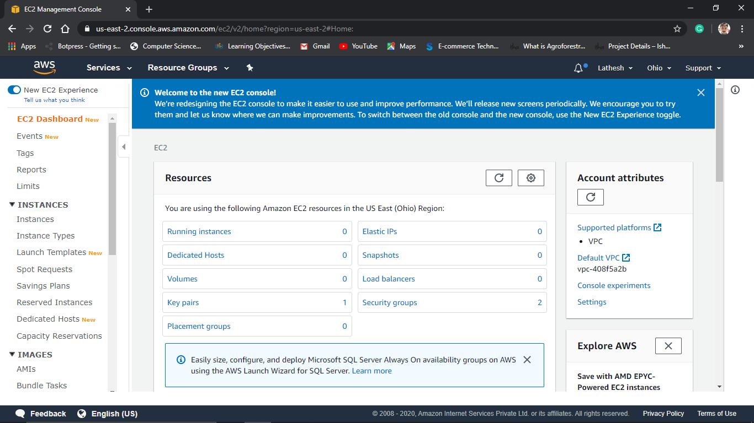

3. S3 Dashboard

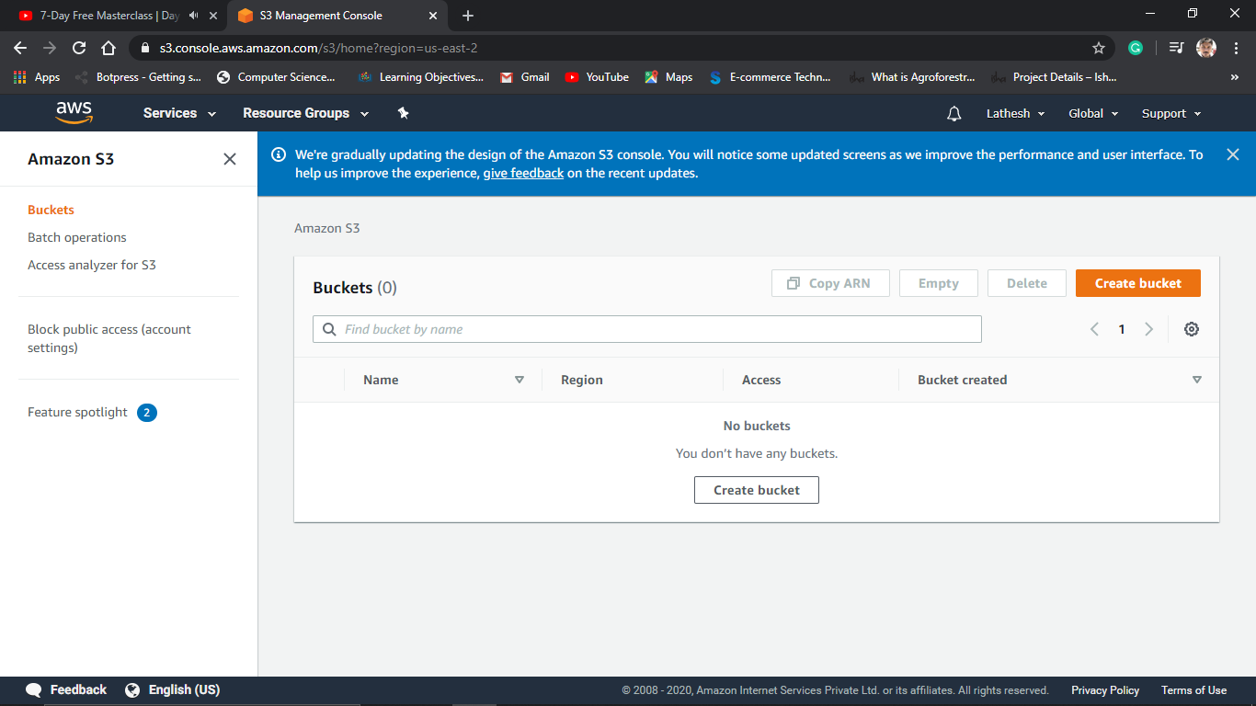

4.Rekognition Dashboard

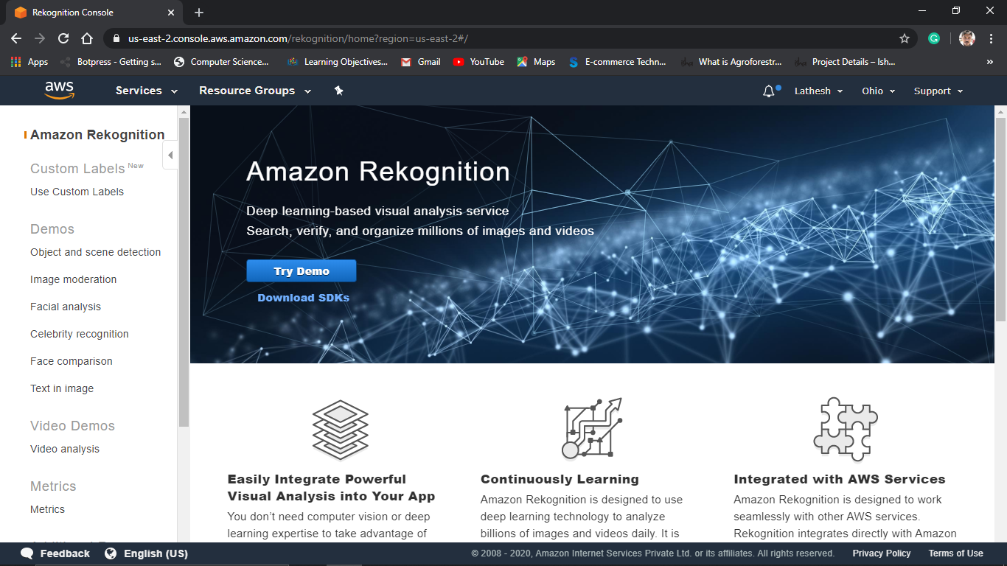

**SCREENSHOTS FOR EC2**

1. Choosing an AMI

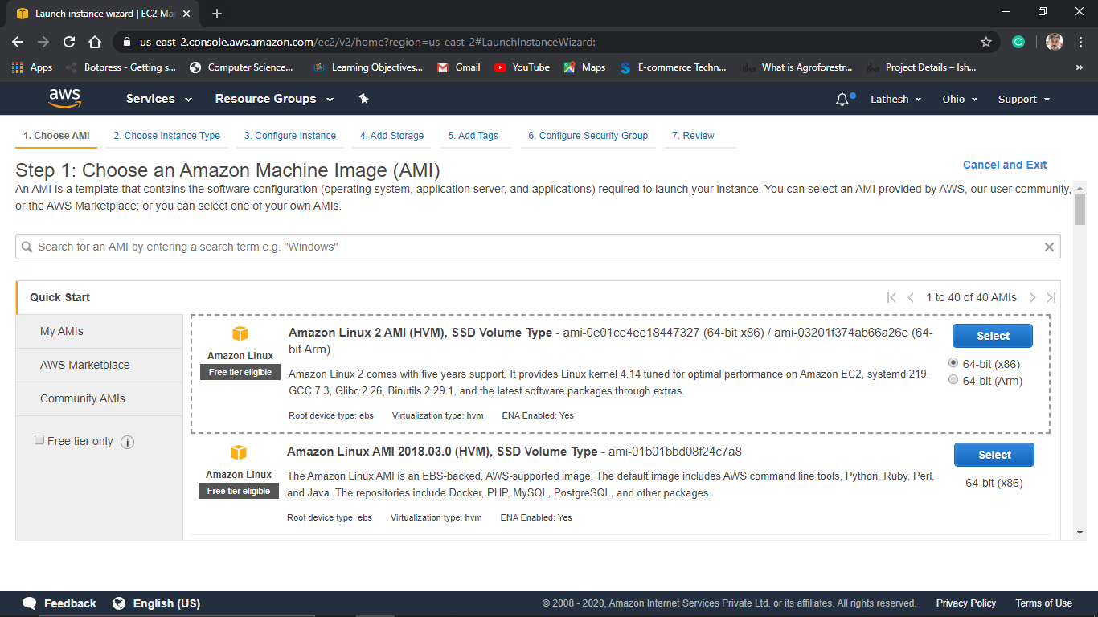

1. Choosing an Instance type

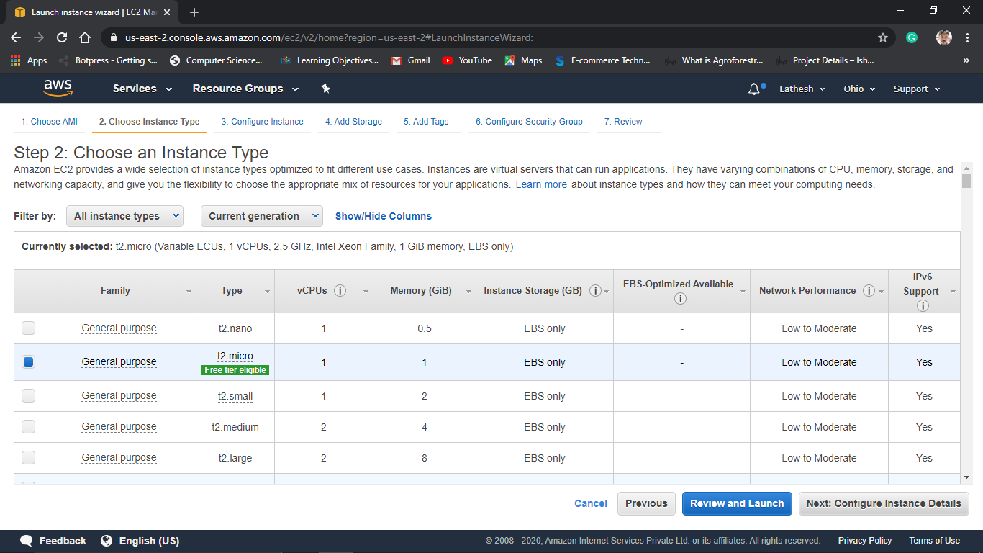

1. Adding Storage

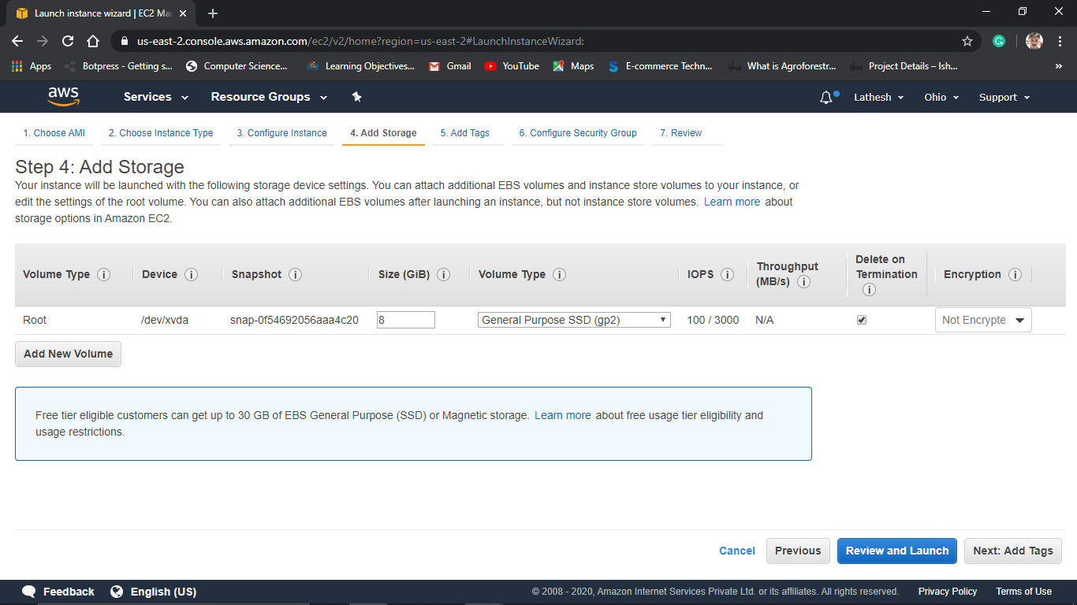

1. Configuring Security Group

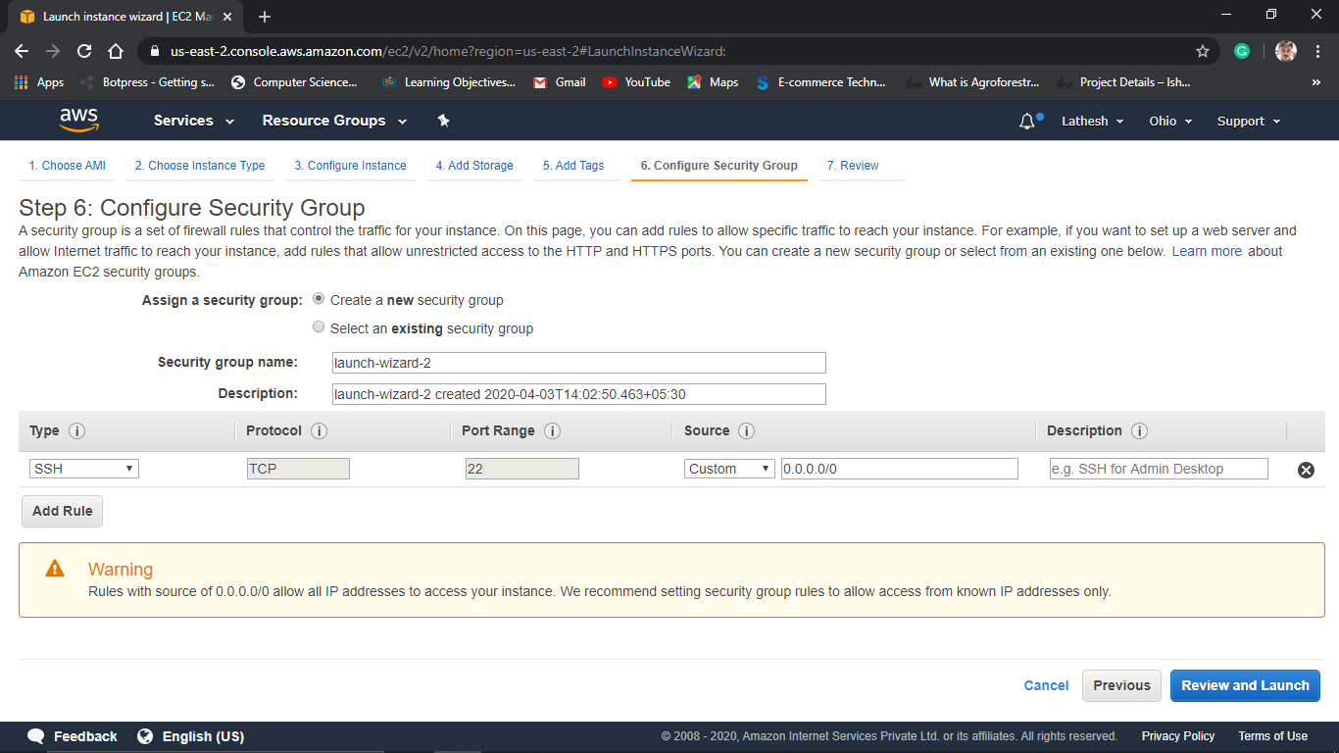

1. Key pair Download

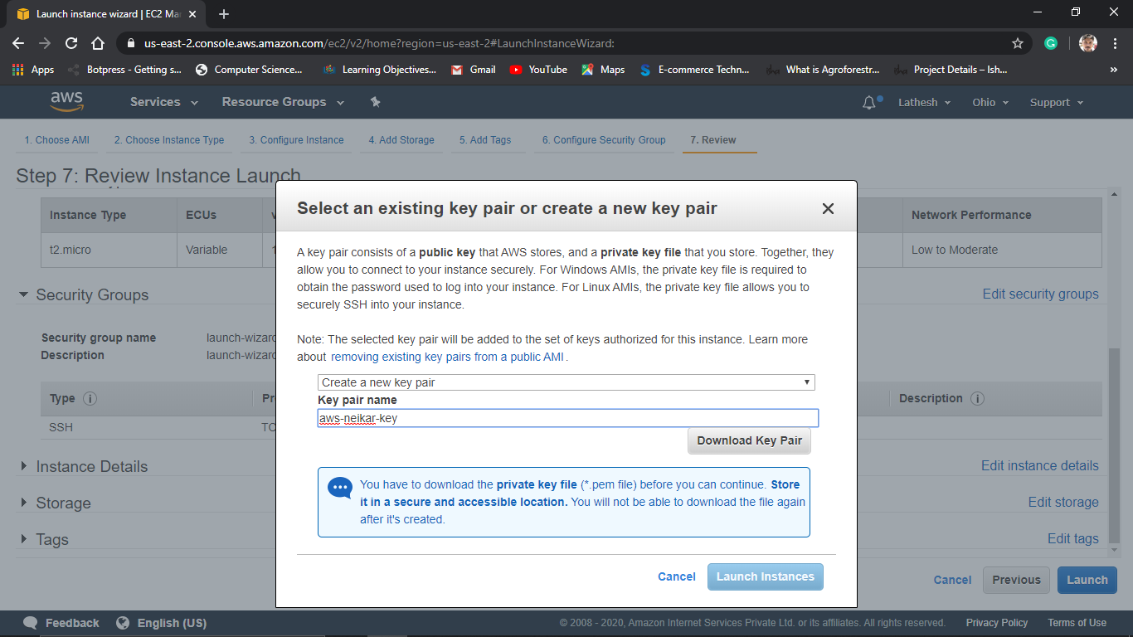

1. PuTTYgen conversion from pem to ppk

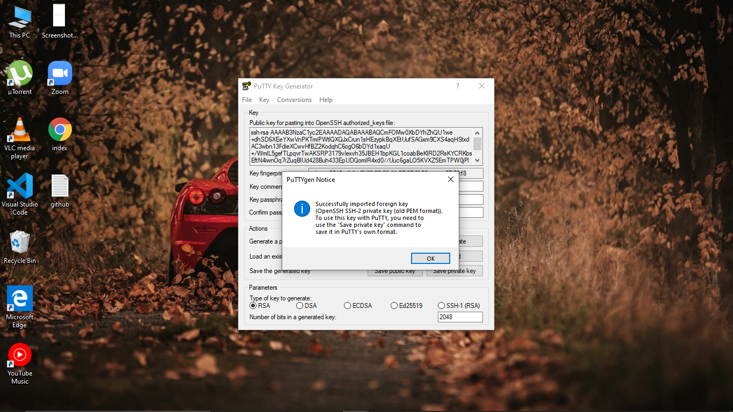

1. Logged in EC2 black screen

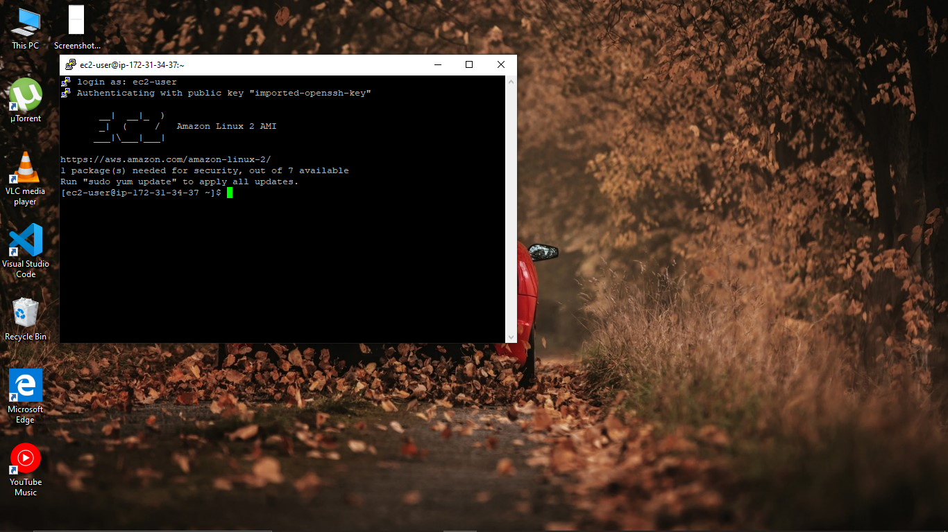

**SCREENSHOTS FOR S3**

1. Creating a bucket

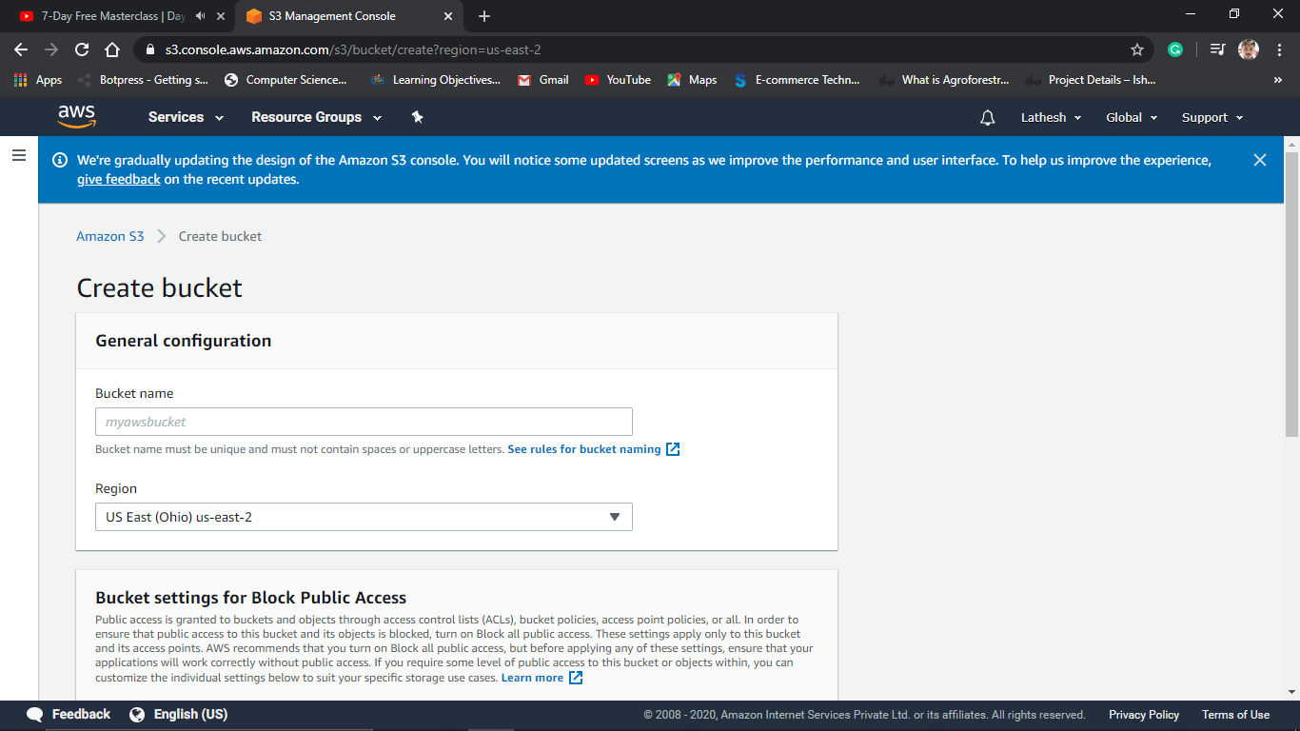

1. Uploading an object

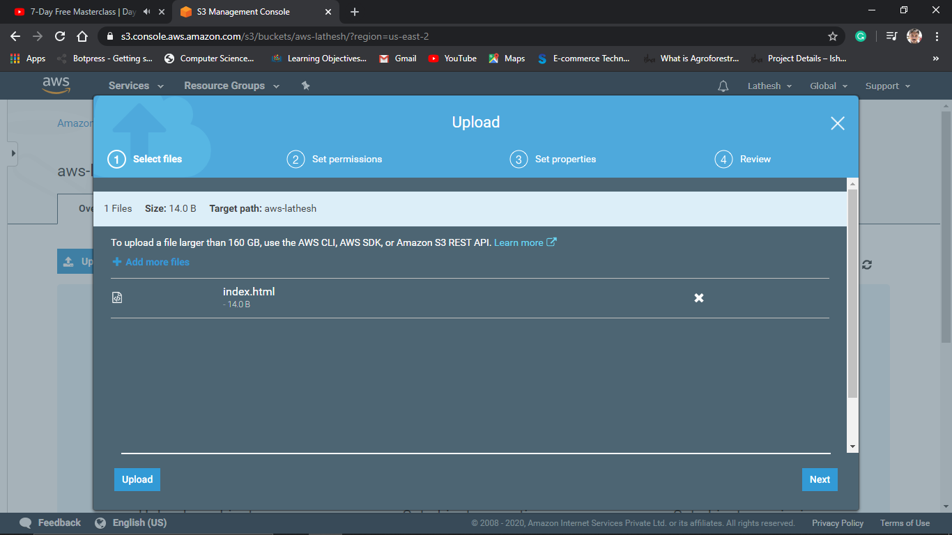

1. Enabling static website

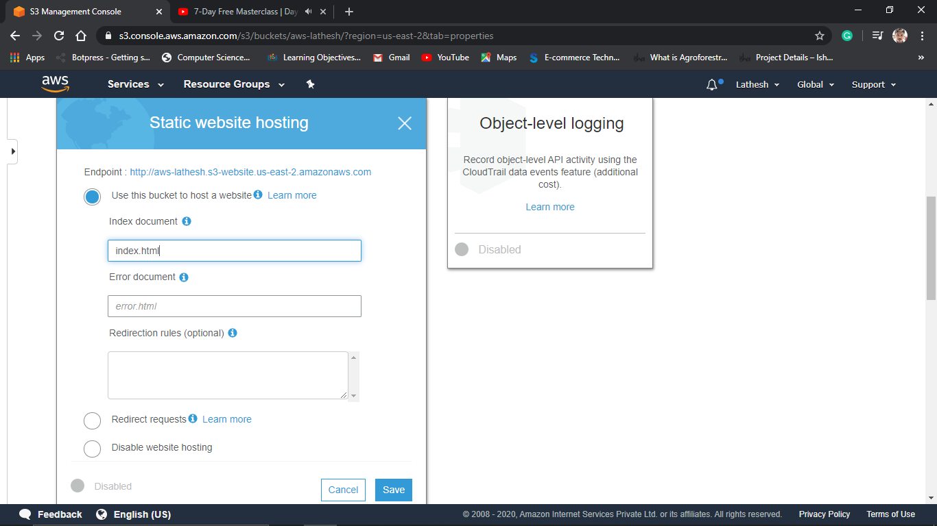

1. Making the object Public

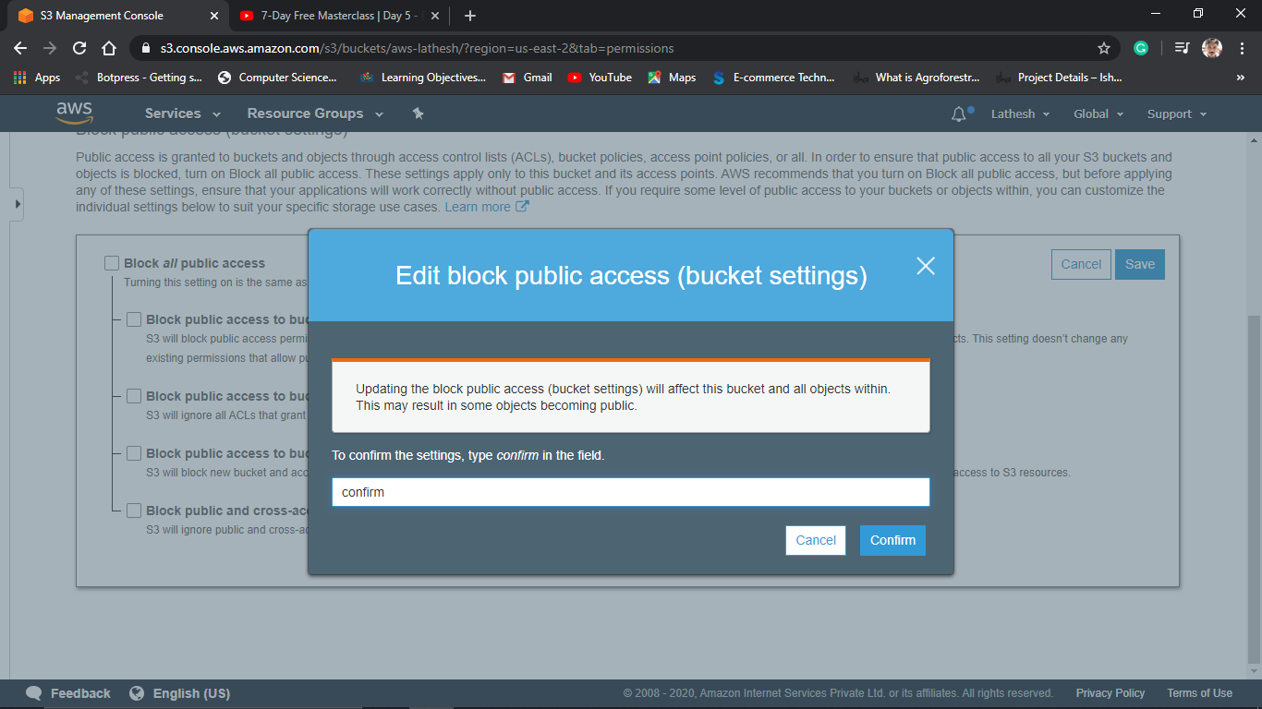

1. Checking S3 link on the browser

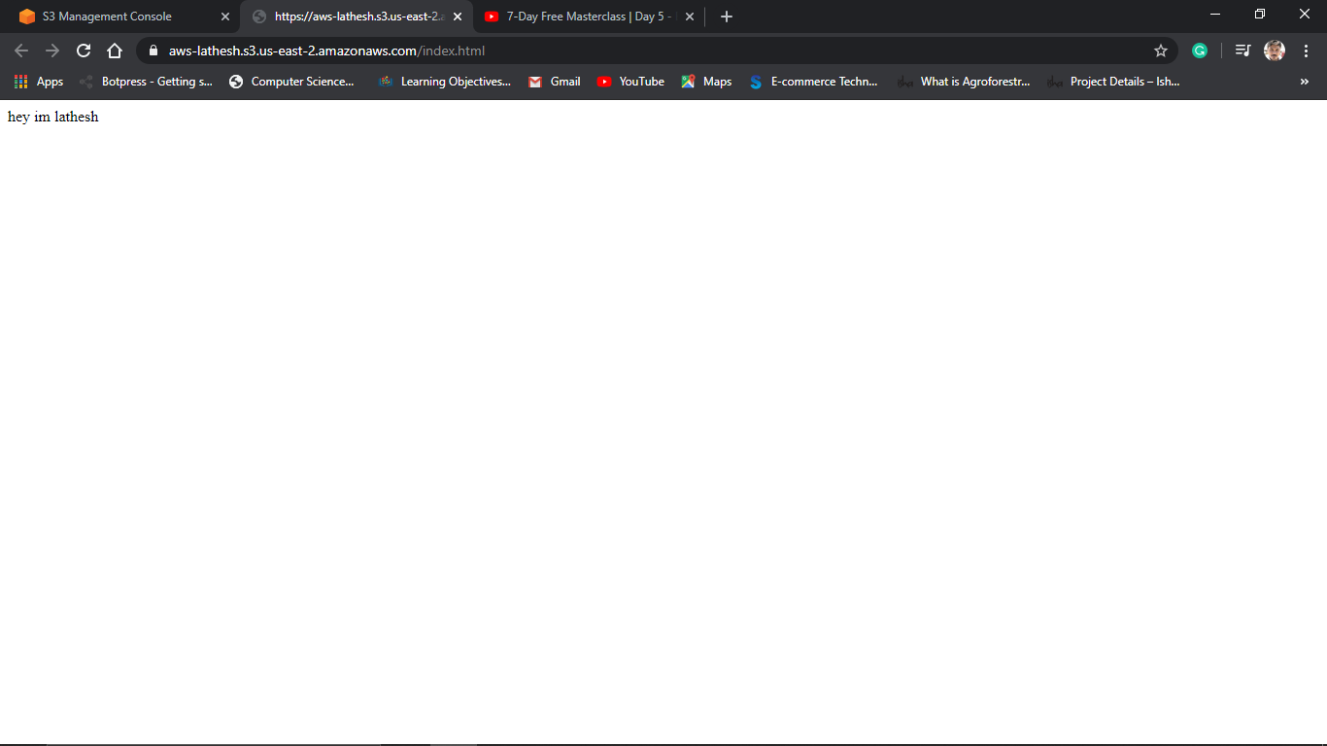

**SCREENSHOTS FOR EC2 and S3**

1.Installing aws-sdk

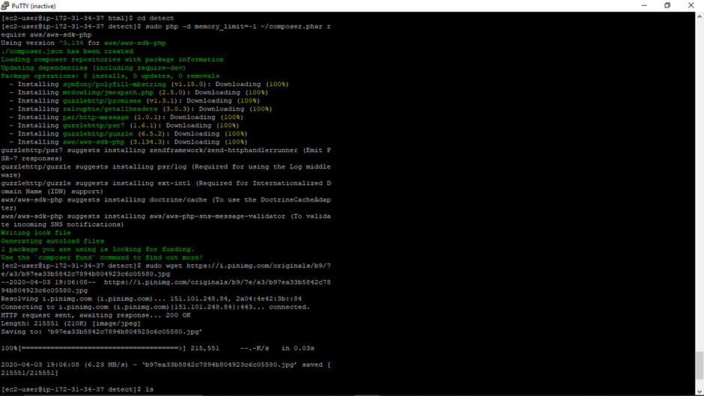

2.Installing php

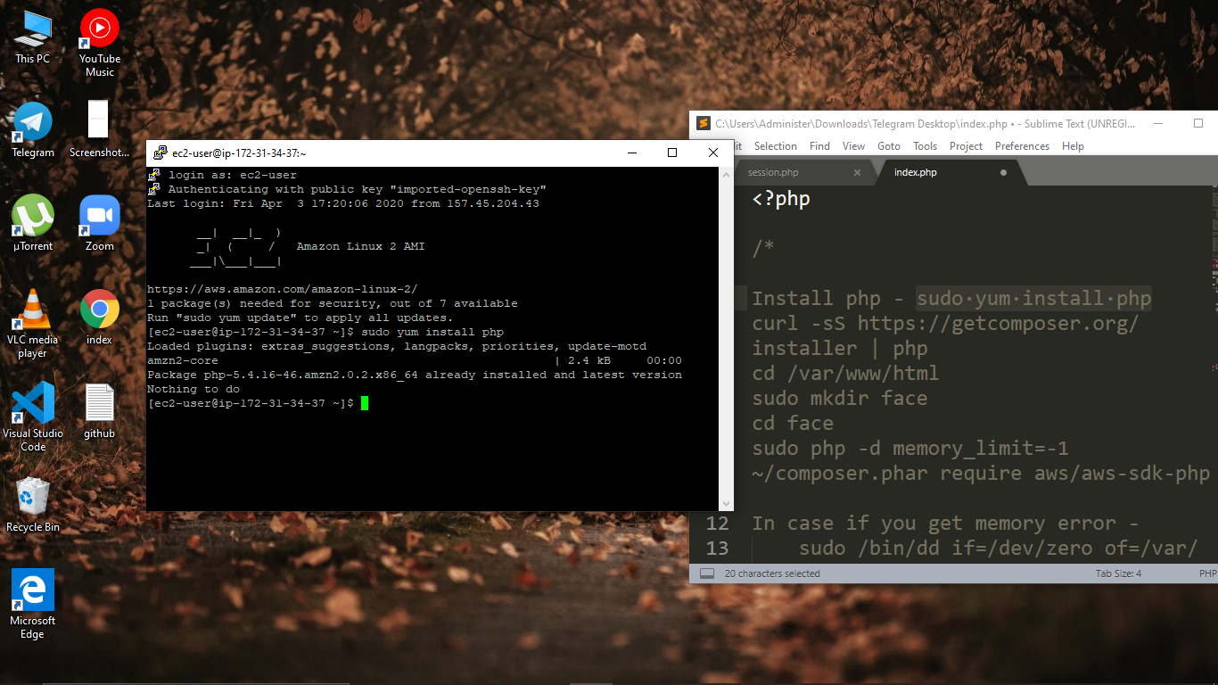

3.Index.php code

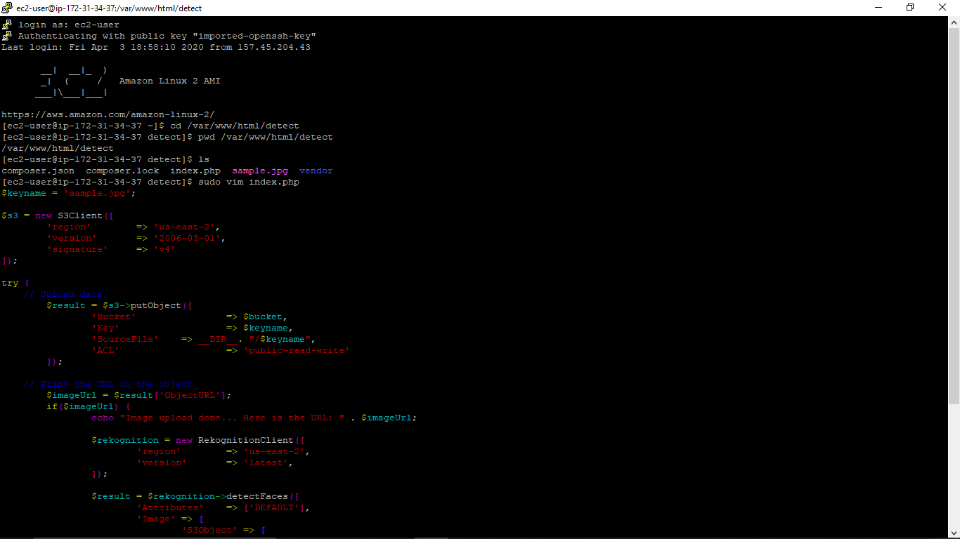

4.upload success screenshot

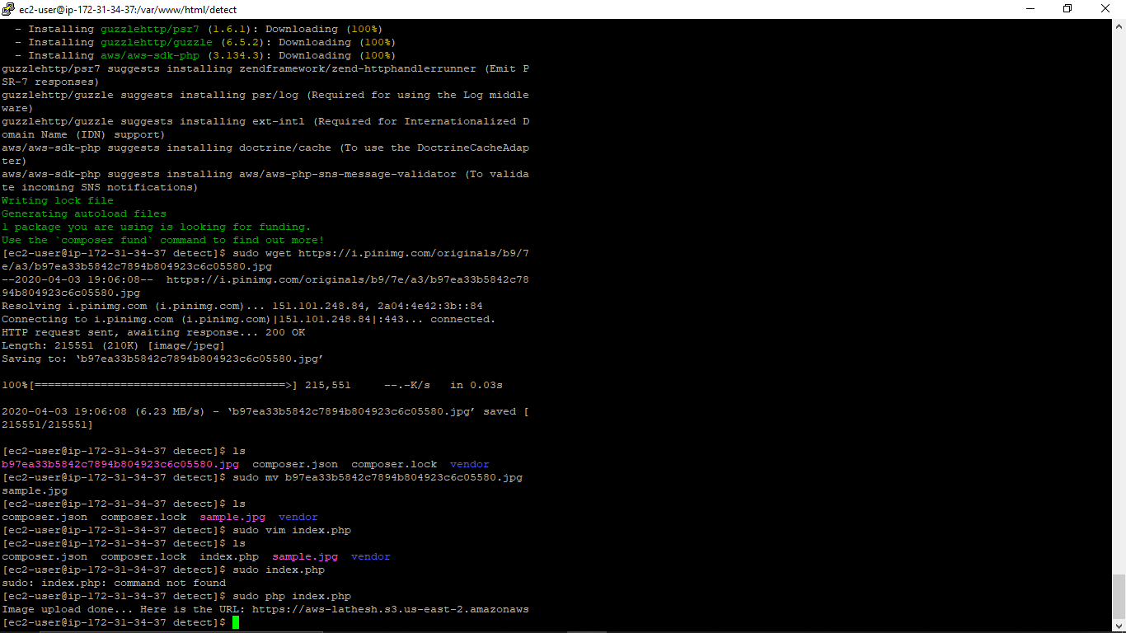

**SCREENSHOTS FOR Rekognition**

1.Face detect

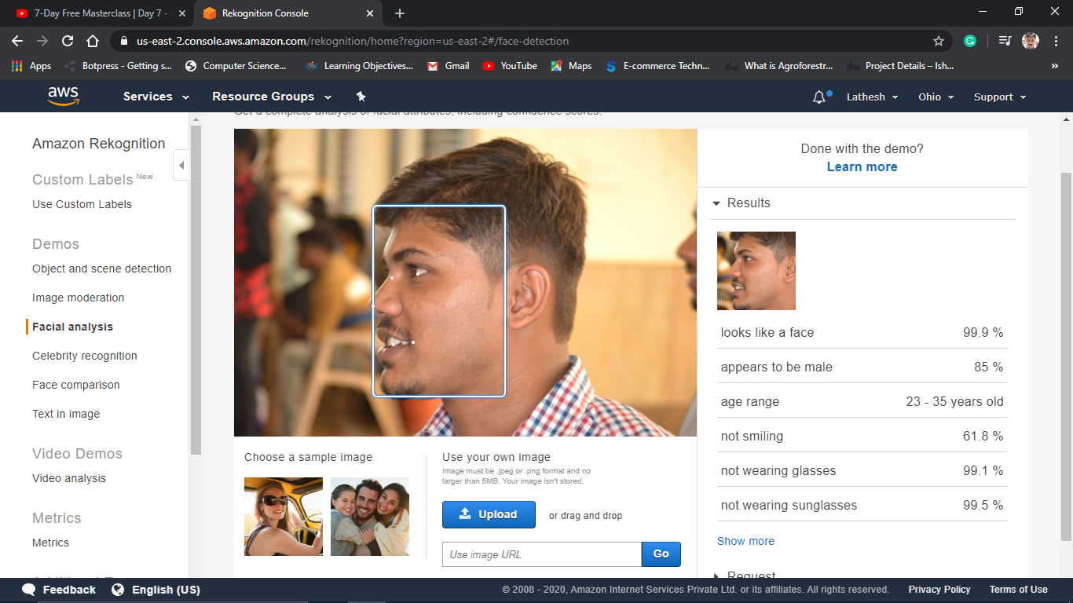

2.Face compare

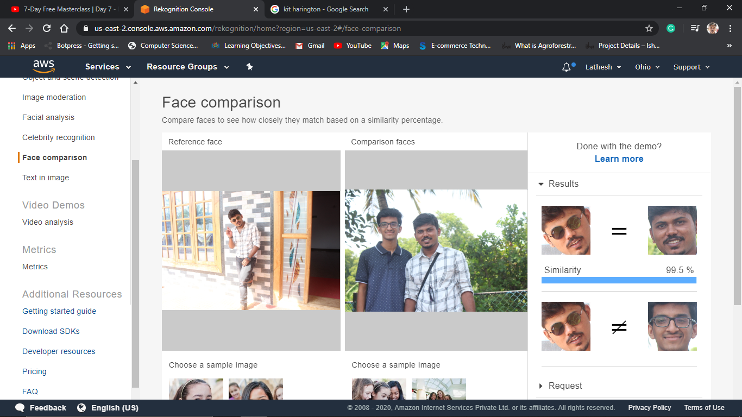

3.Celebrity Rekognition

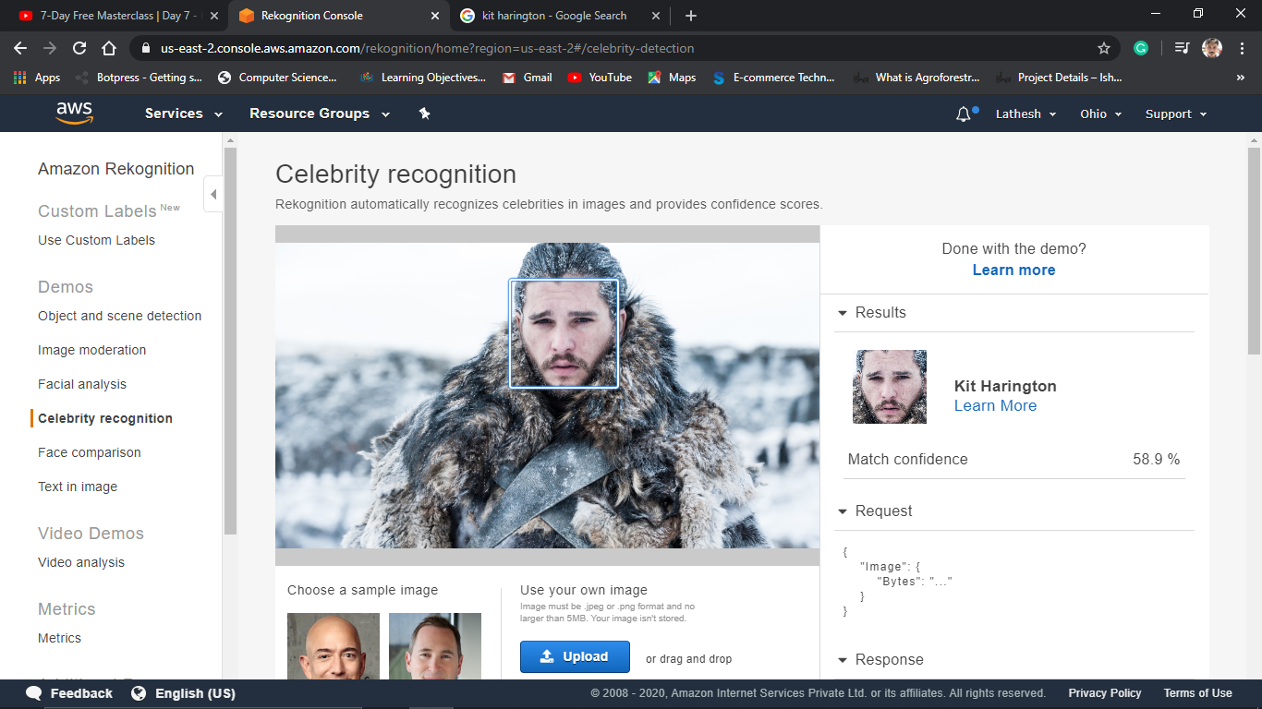

4.Text in image

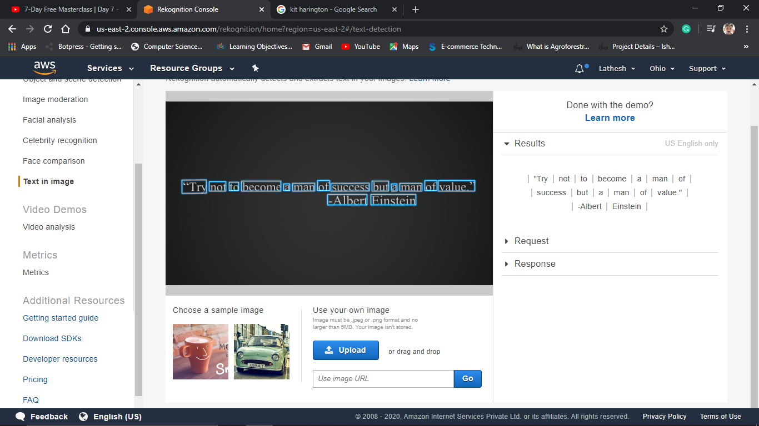

**SCREENSHOTS FOR EC2 and Rekognition**

1.Face detected success screenshot

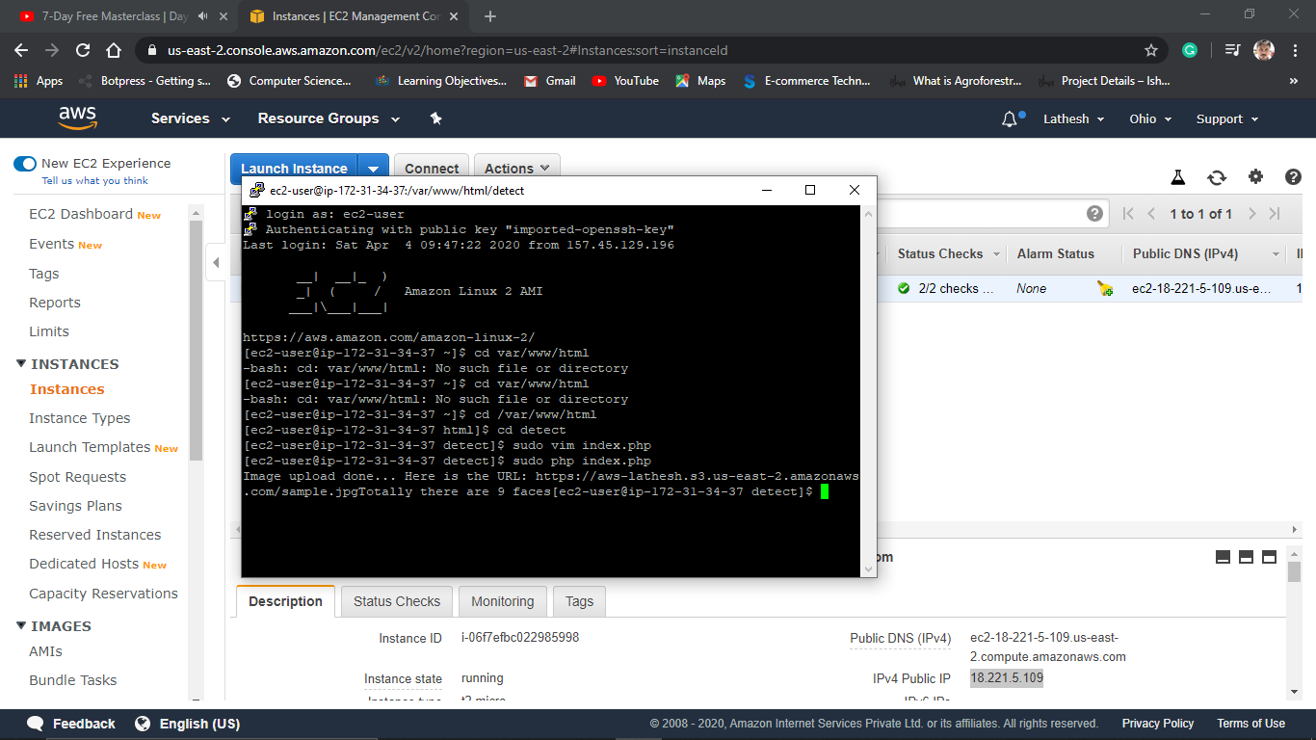

**Thank YOU**